Lesson 0: An introduction to special relativity
Albert Einstein developed the special theory of relativity (or special relativity) in 1905. Before special relativity, there were a number of problems with the classical explanations of electromagnetism which in Einstein's view contradicted the principle of relativity.
Special relativity is based on two simple postulates:
1. The special principle of relativity: The laws of physics are the same for all observers, regardless of their velocity.
2. The speed of light in a vacuum (c) is constant: That is, everyone will always measure the speed of light as being the same (i.e. c = 299,798,458 m/s), regardless of their own velocity.
The important point here is that the speed of light is the same for all observers. Suppose you measure the speed of a beam of light travelling towards you and record it's speed as c. According to Newtonian (or classical) physics, if someone else travelling at 1 m/s (relative to you) were then to measure the speed of a beam of light travelling towards them, then they would measure the speed of light to be c + 1 m/s. However, this does not prove to be the case in practice - everyone records the same speed of light regardless of their velocity relative to each other. Einstein explained this by proposing that the way you view space and time to be different from the way the other person views space and time. The mathematical description of this became the special theory of relativity.
Special relativity remained controversial for many years after it's first publication. However, as experiments became more accurate, special relativity was accepted by the scientific community. Despite this, Einstein did not recieve a Nobel prize for this work - he was granted that honour for his work on the photo-electric effect.
The special relativity simulator, Warp, is an attempt to explain some of the strange consequences of special realativity. What does it mean that my view of space and time is different to your view? Well, if you follow the next few lessons and have a play with Warp then hopefully you will understand...

Lesson 1: Changing the View
Warp consists of a three-dimensional environment that may be navigated using the mouse or the keyboard. When Warp starts, the you should be presented with the following screen:
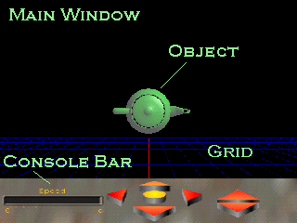
In this case the object is a teapot viewed from above. This isn't obvious at first, so we need to change our point of view. The viewpoint can be changed by using the arrow buttons on the Console Bar. It is also possible to use the keypad to achieve the same effect.
- Keys '4' and '6' move the camera horizontally left and right respectively.
- Keys '8' and '2' move the camera vertically up and down respectively.
- Keys '5' and '0' move the camera into and out of the screen respectively.
That said, you might prefer to use fixed movement axes. This means that the arrows on the Console will always move the camera along the axes of the Warp universe. If this sounds like a good idea then press 'r' to change into this fixed axis system. While this may not seem like a good idea at first, it becomes more useful later, so keep it in mind.
- Press 'r' to toggle 'camera relative' mode on / off.
Note that if you go inside the teapot you will see the teapot as a wireframe. This is because Warp tries to save computing time by not drawing the inside (or in some cases the back) of objects. Normally this isn't a problem, but if it ever does bother you, just press 'b'. This will force Warp to draw everything properly. The downside it that Warp may run slower.
- Pressing 'b' will force Warp to draw the inside (or back) of objects. Pressing 'b' again will return Warp to normal.
The wireframe inside of the teapot is shown below.
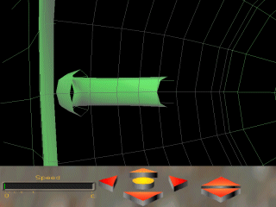
It is also possible to rotate the camera by clicking and dragging with the left mouse button within the Main Window. This can be a little confusing but the blue grid beneath the object should allow you to keep your bearings. I recommend that whenever you want to move around the object, you should align the camera in the direction of the z-axis. This is shown by a red line on the Grid. At the end of the line there is a red '+' so you will know which direction the camera is facing. Camera rotation can also be done using the keyboard.
- Keys '[' and ']' rotate the camera up and down respectively.
- Keys ',' and '.' rotate the camera left and right respectively.
The object orientation can also be changed. Clicking and hold the right mouse button. The blue grid will appear again. Then drag the mouse. The object will rotate about its centre point until you are happy with its orientation, as shown below.
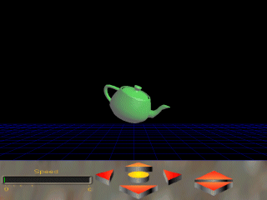
Alternatively, you can use the arrow keys to rotate the object to its desired position. Changing the view might be slow and jerky on slower computers. You might be able marginally improve performance by using the following options:
- Pressing 'w' will make Warp switch to 'wireframe' mode. Pressing 'w' again will change back to 'solid' mode.
- Pressing 'c' will make the Console Bar disappear. This is also useful for revealing parts of the object that may be hidden behind the Console. You can still rotate the camera and object using the mouse, but you will need to use the keyboard to change the position of the camera. Pressing 'c' again will bring back the Console.
- Pressing 'g' will toggle the Grid on / off. However, this can make moving around the object confusing.
A screen showing a wireframe teapot with no console is shown below.
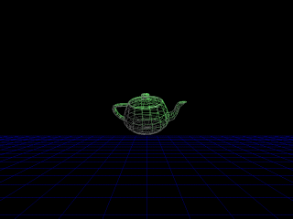
Now you can move about the camera, you are ready to do some experiments with special relativity! To find out how, continue to Lesson 2.

Lesson 2: Experiments at High Speed!
Having mastered the control of the camera, you are now ready to see Warp do what it was designed to do. That is showing you what things would look like at (very) high speeds. To change the speed you need to use the Speed Bar on the left hand side of the Console Bar, as shown below.
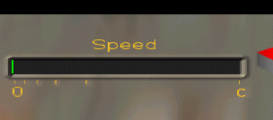
The green line indicates your current speed in the direction of the z-axis of the Warp universe. The z-axis is directly into the screen when you start Warp, and the camera's velocity is always along this axis. By clicking with the left mouse button on the Speed Bar and dragging the mouse, you can change your speed. The line will change size to indicate the speed. Furthermore, its colour will gradually change to yellow as you get close to the speed of light. The scale of the Speed Bar is logarithmic. This means that the Speed Bar is clearer at higher speeds. For example, leftmost tick mark (the one above the '0') indicates a speed of 0 m/s. The rightmost tick mark (the one above the 'c') indicates the speed of light (exactly 299,792,458 m/s !). The marks in-between from left to right indicate 20%, 40%, 60% and 80% of the speed of light respectively. This logarithmic scale allows you to vary your speed more sensitively as you approach the speed of light. Instead of using the mouse, it is possible to change your speed using the keyboard, which can be more sensitive than the mouse.
- Press 'a' to increase your speed.
- Press 'z' to decrease your speed.
This is all well and good, but the exciting stuff happens in the main window. Try this . . .
- Rearrange the camera and teapot so that it is off centre.
- Increase the speed gradually from 0 m/s to about 90% of the speed of light.
- You should see the teapot shoot of into the distance. Don't worry! This is meant to happen! More about this in Lesson 3, but for now bring back the teapot by holding down the space bar. The teapot will come rushing towards you. Let go of the space bar when the teapot is nearby. If the teapot went too far, hold down return to bring it back.
You'll probably see something a bit like below . . .
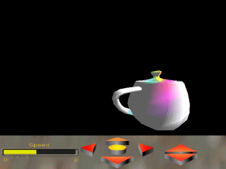
Wooahh! What's going on here? Our teapot has been hideously deformed. And it changed colour. And, is it just me, or did it get brighter too? Well, I'm sure the physicists among you will tell us that this is all down to Einstein's Theory of Special Relativity. In fact there are three different effects going on here.
- Lorentz Transformations
- Doppler Effect
- Headlight Effect
We will explain these one at a time in later lessons. But first, try holding down the 'space bar' again. You should see the teapot shoot of past you. What you are doing is setting time in motion. Whereas before time was frozen and you were seeing a snapshot of the teapot, by pressing the 'space bar' you increase time by a small amount. The teapot there for starts moving because of it's velocity relative to the camera. You can reverse time by pressing 'Return'. And if things get completely out of hand, you can set the time back to zero by pressing 't'. So just for completeness . . .
- Press the 'space bar' to increment the time in the Warp universe.
- Press 'Return' to reverse increment the time.
- Press 't' to reset the time.
Anyway, now that's sorted, you are ready to learn about Lorentz Transformations in Lesson 3.

Lesson 3: Lorentz Transforms Explained
Ergh! What a nasty sounding title. But it's not that bad. No really! First, think of an experiment . . .
Two spaceships, A and B, are driving towards each other. A spaceman, who is sitting still in space, sees both spaceships going at 1,000,000 m/s (one million metres per second). The pilot in spaceship A wants to know how fast spaceship B is approaching him. In pre-Einstein physics (i.e. before special relativity) he would assume that spaceship B approaching him at 2,000,000 m/s.
Spaceship B then slows to a halt. The pilot decides to do an experiment and measure the speed of light. He measures the speed of a ray of light heading towards him. He gets a result of 300,000,000 m/s (that's three-hundred million metres per second).
Meanwhile, spaceship A is still going at 1,000,000 m/s. The pilot also decides to measure the speed of a ray of light coming towards him. What result does he get?
- 301,000,000 m/s (three-hundred and one million metres per second)?
- 299,000,000 m/s (two-hundred and ninety nine million metres per second)?
- 300,000,000 m/s (three-hundred million metres per second)?
- Eh?
If you said '2' or '4' then go back and reread this lesson from the beginning. If you said '1' then nearly every physicist in the world would agree with you . . . up until 1905 and Einstein that is. The correct answer is '3' because the speed of light is the same for all observers. This is what special relativity is all about. It doesn't matter if you are traveling at 200,000,000 m/s or standing still, you will always get the same result for the speed of light. A Dutchman named Hendrik Antoon Lorentz realized that this could be explained if objects in motion undergo transformations called the Lorentz Transformations.
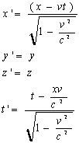
In these equations x, y, z and t set the coordinates of space and time respectively from an observers point of view. Also, x', y', z' and t' set the coordinates according to the subject. The velocity, v, is in the direction of the x-axis and c is the speed of light. So what does this mean? Well, it means that funny thing happen to the way things look. For example, the first image shows a stationary lattice. The second image shows the same lattice traveling towards us at close to the speed of light! Notice how you can see the back of some of the lattice members despite the fact that they are in front of you! Very strange.
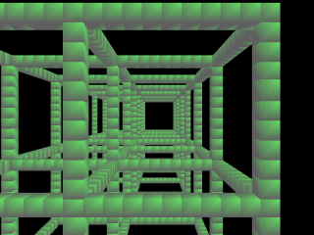
v = 0 m/s
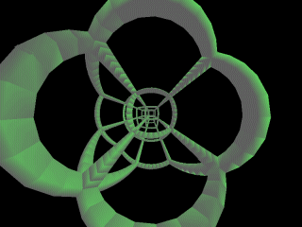
v -> c
Warp simulates the Lorentz Transformations, and it is worth pointing out that if you try moving around a warped object you might find it a bit strange. First of all, as you increase the speed, the object will generally shoot off into the distance. Why? Well, look at the first equation given in this lesson. You see that if we increase the velocity, v, but hold the time, t, constant then x' will diverge from x. Of course in real life it's impossible to increase your speed instantaneously but this is exactly what happens in Warp. Warp holds time still until you tell it otherwise. Remember in the Lesson 2 when the teapot went shooting off as you increased the speed? Well you are now in a position to understand what was going on. The speed was increased, the time wasn't, so x' became large and hence the teapot shot off into the distance. Simple.
The result of all this waffle is that when you change you speed in Warp, you will also have to change the time. As outlined earlier, you do this using 'space' and 'return'. If you forget to do this, your object will disappear off the edge of the Warp universe, and you'll be terribly upset.
Anyway, the object may behave in unpredictable ways because of the way that the twisting at high speeds. If you don't want to get thoroughly confused when moving around objects I recommend reducing the speed before moving. I also find that it is easier to work with the camera fixed on the axes of the Warp universe as outlined in Lesson 1. If you recall, this involved pressing 'r' to toggle the 'camera relative' mode.
That said, if you do want to be completely perplexed, please try moving / rotating the teapot around at high speed and see what happens!
Moving on, the observant among you will have noticed that the colour of objects in Warp also changes. This is due to Doppler Shifting, which we talk about in Lesson 4

Lesson 4: All the Colours of the Rainbow - The Doppler Effect
Okay, those of you with good memories will recall that the teapot in Lesson 1 changed colour as we increased the speed. This is all down to the good ol' Doppler Effect. For those of you who don't know what that is, let me explain . . .
Remember the last time you heard an ambulance go by? Remember how the pitch of the siren changed as the ambulance went past? That's the Doppler effect. The sound waves emitted by the siren get squashed up as the ambulance comes towards you, and hence the siren seems high pitched. Likewise, when the ambulance has passed, the sound waves are stretched out and hence you hear a low-pitched siren.
Light also behaves like a wave (except in Quantum Mechanics, but Einstein didn't like Quantum Mechanics so we'll pretend it doesn't exist (!)). Therefore, it is subject to exactly the same effect. Light emitted from an object rushing towards us will have its waves squashed up. Hence, the colours will be shifted towards the blue end of the spectrum. Conversely, light waves from an object rushing away from us will appear redder. These changes are called blue shift and red shift respectively. At very high speeds visible light emitted by the object can be shifted out of the visible spectrum, and hence the object would not be visible to the human eye!
The original wavelength is shifted according to the following formula:
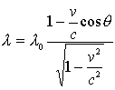
Here, lambda is the wavelength, v is the speed, and theta is the angle that the vector to the point on the object makes with the direction of motion (for those who are interested).
Warp simulates the Doppler effect on fast moving objects. In order to see this, try the following:
- Set the speed to zero and arrange the object to your preference.
- Press 'h'. This turns off the Headlight effect, which we are not interested at the moment, but we will come back to later.
- Now hold down 'a' to increase the speed slowly.
- As ever, use 'space' and 'return' to get the object back on the screen.
You will notice that the colour of the object slowly changes. You may even end up seeing bands of colour. This is due to the angle term in the pervious equation. You may end up seeing something like this:
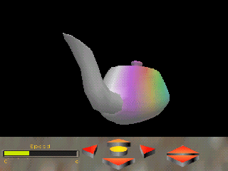
As you can see the object suddenly turns white (like the left hand side of the teapot above). This means that the colour has been shifted out of the optical spectrum. In reality it would no longer be visible, but Warp shows this as white to aid visibility.
The Doppler effect is the reason that Warp draws everything in green to start with. Green is in the middle of the optical spectrum, so you are able to get a good range for both red and blue shifting. However, if you are only interested in, say, blue shift (objects coming towards you), then you can change the original colour of the objects. To do this you need to use the '+' and '-' keys, which will slowly change the hue of an object until you are happy. So if you are interested in blue shifting you might want to start of with a red teapot to give yourself the largest possible colour range to play with.
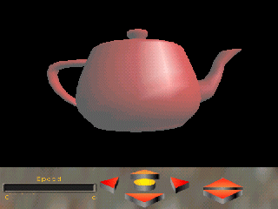
- Use '+' and '-' to change the hue of the object.
However, sometimes you won't want to see the Doppler effect. After all, those colours can be a bit hard on the eyes. So . . .
- Press 'd' to turn off the Doppler effect. Press 'd' again to turn it back on.
You now know all about the Doppler effect and how colour is used in Warp. However, you might remember that I mentioned the 'headlight effect'. Well, this is another interesting phenomena of special relativity and is the subject of the next lesson.

Lesson 5: Bright Lights - The Headlight Effect
We now turn our attention to one of the stranger effects of special relativity, the headlight effect. The best way to explain this is to imagine a torch that, in its own frame, emits a beam of light in the shape of a cone. This cone's sides make an angle of phi with respect to the x-axis (i.e. the torch is pointing along the x-axis). This is shown in the following diagram.
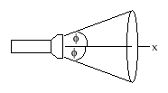
Now imagine that the torch moves along the x-axis with some velocity, v. Contrary to what you might expect, the angle phi will become narrower! This contraction is known as the Headlight effect. The amount that phi narrows is given by the following equation:
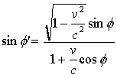
So what does this mean in relation to Warp? Well, the important thing to note is that the torch isn't giving off any less light. The same amount of light is being focused into a smaller area. Therefore, an approaching torch will seem brighter than a stationary torch. Likewise, a receding torch will appear darker. This doesn't just apply to torches. It also applies to any object traveling towards an observer. The change in light intensity, I, is given by the following relationship:
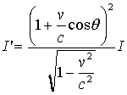.
You can see the headlight effect in Warp by trying the following:
- Arrange the object as you like it.
- Press 'd' to turn off the Doppler effect.
- Increase the speed to some arbitrary value.
- Guess what? Use 'space' and 'return' to alter the time and hence view of the object. Boy, I get tired of saying that!
If you arranged the object so that it is speeding towards you then you should see something like this:
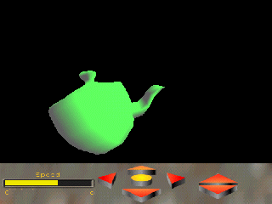
Notice how bright the teapot is. However, if the object is traveling away from you then you should see something more like this:
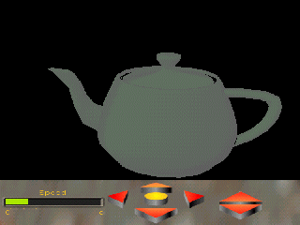
Here the headlight effect has darkened everything to such an extent that you can't see much of the original colour! Of course this can be a bit of a pain so you can turn the headlight effect off:
- Press 'h' to toggle the headlight effect on / off.
Okay, you should now understand all of the relativity effects that Warp simulates. The best way to learn about these things is to have a play around with Warp, and see what you can do. However, by now you are probably bored with the teapot and want to try other things. Well, that's the subject of the next lesson.

Lesson 6: Odds and Ends
Well you've more or less seen it all. But a couple of things still remain . . .
1: Loading Other Objects!
By now you'll be totally bored with the teapot. Luckily, Warp supports other objects. First you'll need to visit the Download page to download some models. Once you've unzipped these onto your computer, simply click on the big yellow button in the middle of the console. This will bring up a box that will allow you to load the new objects. May I recommend the lattices, as they make visualising special relativity a lot easier. Most of the objects are great fun, for example I bet you've never seen the Eiffel tower like this:
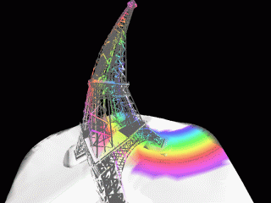
2: Keyboard short cuts.
You might be overawed with all the keyboard shortcuts used by Warp, but don't worry! Simply press F1 to bring up a little help box to remind yourself of all the keys! Hurrah! Or you can look at the next lesson for a quick summary.

Lesson 7: Summary
Keyboard commands:
- Press F1 to bring up the help screen.
- Keys '4' and '6' move the camera horizontally left and right respectively.
- Keys '8' and '2' move the camera vertically up and down respectively.
- Keys '5' and '0' move the camera into and out of the screen respectively.
- Press 'r' to Toggle 'camera relative' mode on / off.
- Keys '[' and ']' rotate the camera up and down respectively.
- Keys ',' and '.' rotate the camera left and right respectively.
- Use the Arrow Keys to rotate the object.
- Pressing 'w' will toggle 'wireframe' mode.
- Pressing 'g' will toggle the grid on / off.
- Pressing 'b' will toggle 'back face' culling.
- Pressing 'c' will toggle the Console on / off.
- Press 'a' to increase your speed.
- Press 'z' to decrease your speed.
- Press the 'space bar' to increment the time in the Warp universe.
- Press 'Return' to reverse increment the time.
- Press 't' to reset the time.
- Use '+' and '-' to change the hue of the object.
- Press 'd' to turn off the Doppler effect. Press 'd' again to turn it back on.
- Press 'h' to toggle the headlight effect on / off.
- Press 'o' to open a new object file.
- Press 'Esc' to Exit Warp.
Well done! You've made it to the end, and you now know all there is to know about special relativity (well, sort of). I hope it's not been too dull for you. Have fun playing around!

